Unit 3
- What are the different ways of selecting and filling ranges in Excel
ANS:




- Explain the syntax for count,max,min,sum in Excel
ANS:
1. COUNT Function
Definition: Counts the number of numeric values in a range.
Syntax:
COUNT(value1, [value2], …)
- value1, value2, … → Cells or ranges to count numbers.
Example:
=COUNT(A1:A10)
- Counts how many numeric values are in cells A1 to A10.

2. MAX Function
Definition: Returns the largest number in a range.
Syntax:
MAX(number1, [number2], …)
- number1, number2, … → Cells or numbers to find the maximum.
Example:
=MAX(B1:B10)
- Returns the highest value in cells B1 to B10.

3. MIN Function
Definition: Returns the smallest number in a range.
Syntax:
MIN(number1, [number2], …)
- number1, number2, … → Cells or numbers to find the minimum.
Example:
=MIN(C1:C10)
- Returns the lowest value in cells C1 to C10.

4. SUM Function
Definition: Adds all numbers in a range.
Syntax:
SUM(number1, [number2], …)
- number1, number2, … → Cells or numbers to sum up.
Example:
=SUM(D1:D10)
- Adds all values in cells D1 to D10.

- Explain the syntax for Proper, Upper, Lower, Average in Excel
ANS:
1. PROPER Function
Definition:
The PROPER function is used to capitalize the first letter of each word in a text string and convert all other letters to lowercase.
Syntax:
=PROPER(text)
Example:
=PROPER("hello world") → Result: Hello World
2. UPPER Function
Definition:
The UPPER function converts all characters in a text string to uppercase letters.
Syntax:
=UPPER(text)
Example:
=UPPER("excel functions") → Result: EXCEL FUNCTIONS

3. LOWER Function
Definition:
The LOWER function converts all characters in a text string to lowercase letters.
Syntax:
=LOWER(text)
Example:
=LOWER("WELCOME") → Result: welcome

4. AVERAGE Function
Definition:
The AVERAGE function calculates the arithmetic mean of the given numbers, i.e., the sum of numbers divided by their count.
Syntax:
=AVERAGE(number1, [number2], …)
Example:
=AVERAGE(10, 20, 30, 40, 50) → Result: 30

- How to do concatenation and auto sum in Excel
ANS:
1. Concatenation in Excel
Definition:
Concatenation joins text from two or more cells into a single cell.
Ways to Concatenate:
1.Using & Operator:
=A1 & B1
  - Joins the contents of A1 and B1.
  - Example:
    - A1 = "John", B1 = "Doe" → =A1 & " " & B1 → Result: "John Doe"
2.Using CONCATENATE Function (Older Excel versions):
=CONCATENATE(A1, " ", B1)
  - Joins A1 and B1 with a space in between.
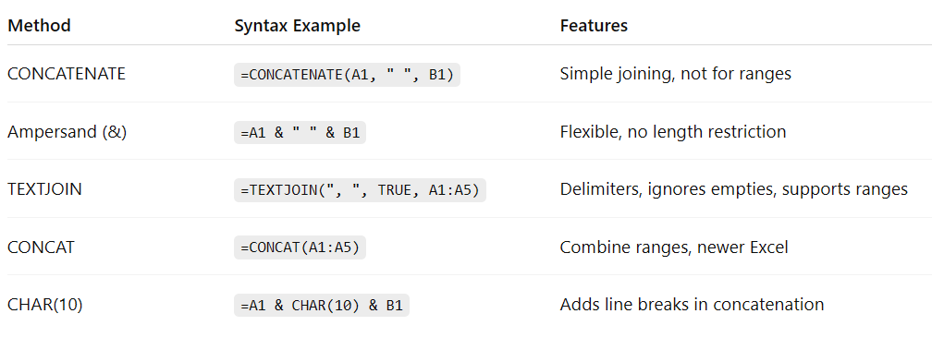

2. AutoSum in Excel
Definition:
AutoSum quickly calculates the sum of numbers in a row or column.
Steps to Use AutoSum in Excel
- Select the cell below a column or next to a row of numbers.
- Go to the Home tab → Editing group → AutoSum (Σ).
- AutoSum is not just for sum — it also allows you to quickly calculate functions like SUM, AVERAGE, COUNT, MAX, and MIN. You can choose whichever calculation you need.
- Press Enter after selecting the function.
- The result (sum, average, count, min, or max) of the selected range appears in the cell.
Example:
- Numbers in cells A1 to A5: 10, 20, 30, 40, 50
- Select A6 → Click AutoSum → Result: 150

- Explain with proper example vlookup and hlookup excel functions in Excel
ANS:

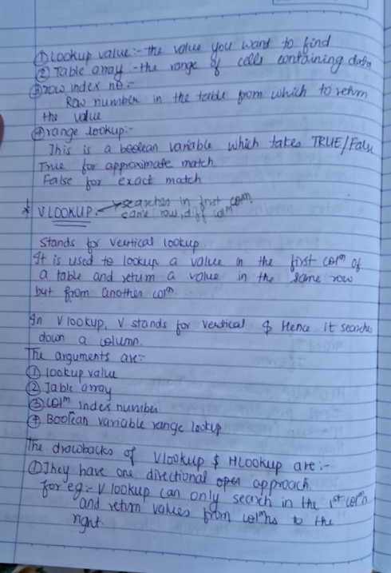
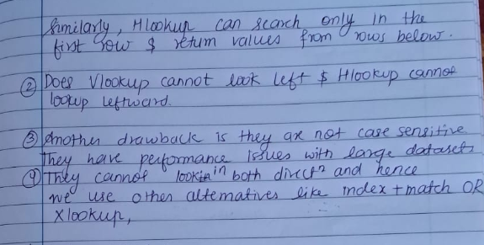

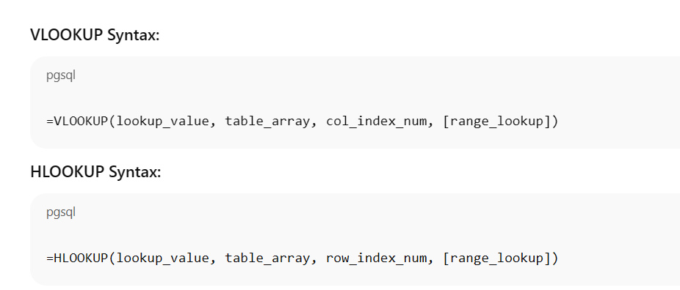
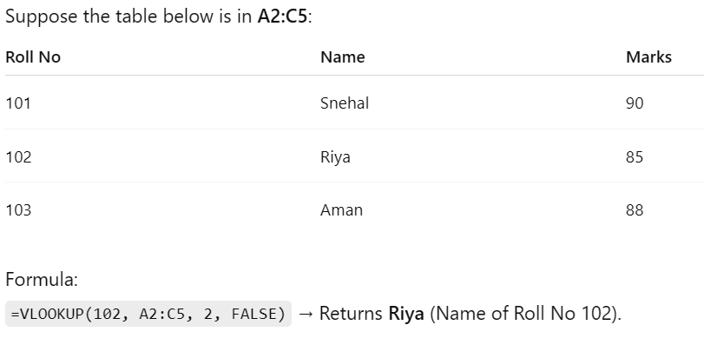
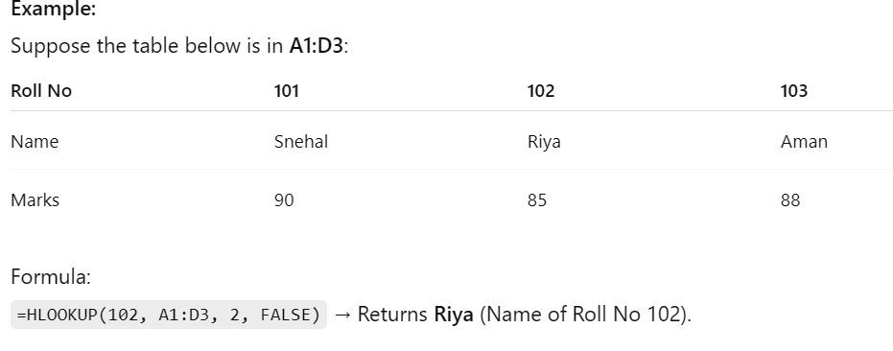

- Explain match and count if functions in Excel
ANS:

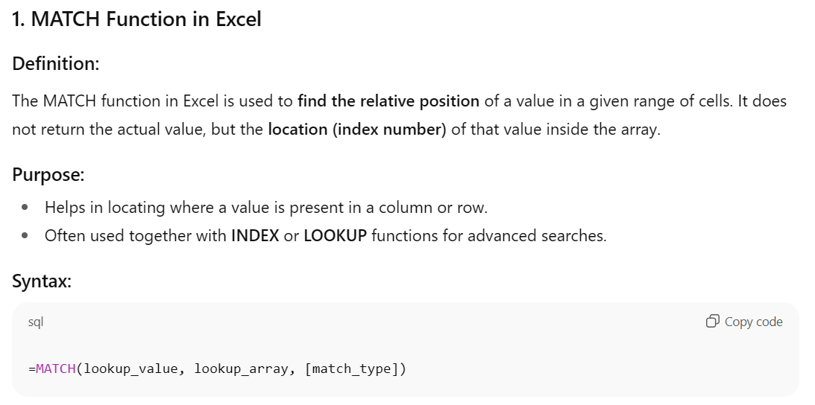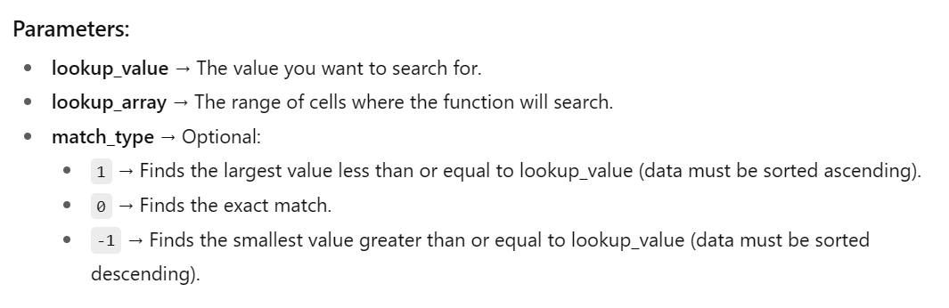
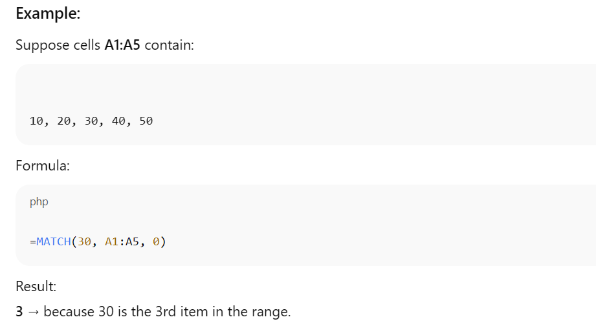
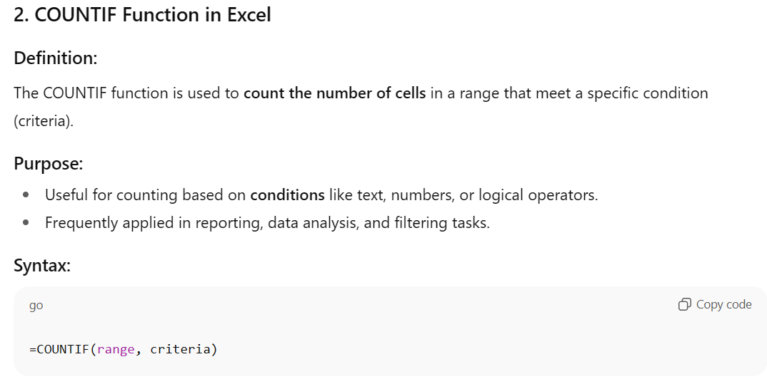
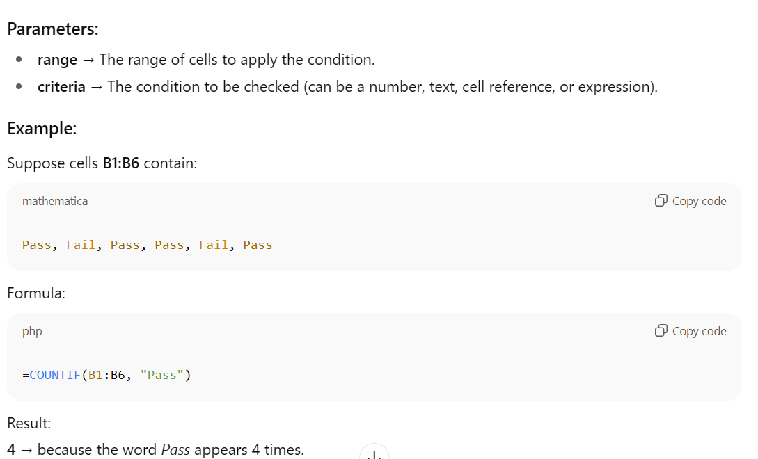

- What are the functions in Excel related to text and trim.
ANS:
Text Functions in Excel
Excel provides several functions to manipulate, clean, and format text. Some of the commonly used text functions are:
1. TRIM Function
Definition:
The TRIM function removes all extra spaces from a text string except single spaces between words. It is useful for cleaning data imported from other sources.
Syntax:
=TRIM(text)
Example:
If A1 = " Snehal Tripathi "
=TRIM(A1)
Result: "Snehal Tripathi"
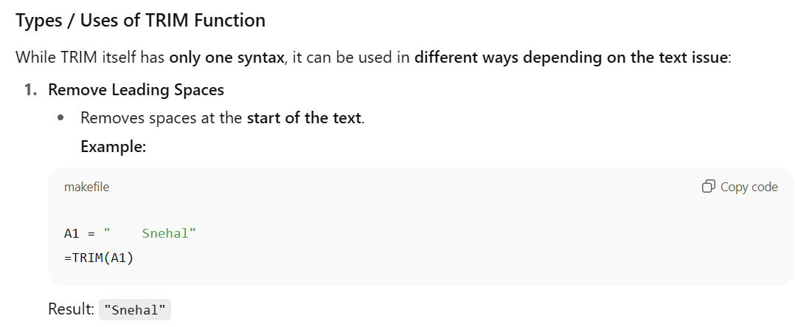



2. UPPER Function
Definition: Converts all letters in a text string to uppercase.
Syntax:
=UPPER(text)
Example:
=UPPER("excel functions") → "EXCEL FUNCTIONS"

3. LOWER Function
Definition: Converts all letters in a text string to lowercase.
Syntax:
=LOWER(text)
Example:
=LOWER("WELCOME") → "welcome"

4. PROPER Function
Definition: Capitalizes the first letter of each word in a text string.
Syntax:
=PROPER(text)
Example:
=PROPER("snehal tripathi") → "Snehal Tripathi"

5. CONCATENATE / CONCAT Function
Definition: Joins two or more text strings into one string.
Syntax:
=CONCATENATE(text1, [text2], …)
Example:
=CONCATENATE("Snehal", " ", "Tripathi") → "Snehal Tripathi"

6. LEFT Function
Definition: Returns a specified number of characters from the start (left) of a text string.
Syntax:
=LEFT(text, num_chars)
Example:
=LEFT("Snehal", 3) → "Sne"

7. RIGHT Function
Definition: Returns a specified number of characters from the end (right) of a text string.
Syntax:
=RIGHT(text, num_chars)
Example:
=RIGHT("Tripathi", 4) → "athi"

8. MID Function
Definition: Returns a specified number of characters from the middle of a text string.
Syntax:
=MID(text, start_num, num_chars)
Example:
=MID("Snehal Tripathi", 8, 6) → "Tripat"

9. LEN Function
Definition: Returns the length of a text string (number of characters including spaces).
Syntax:
=LEN(text)
Example:
=LEN("Snehal Tripathi") → 15

- What are the different types of charts supported by Excel write one use case for each
ANS:
A chart in Excel is a graphical representation of data that makes it easier to analyze, visualize, and compare information. Charts help to identify patterns, trends, and relationships in data quickly, which is difficult to see in raw numbers.
Different Types of Charts in Excel
1. Column Chart
Definition: Represents data using vertical bars to compare values across categories.
Use Case: Compare monthly sales of different products.
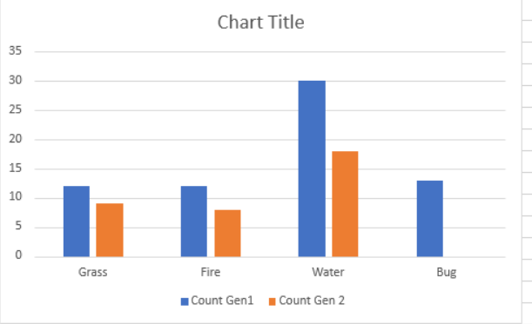
2. Bar Chart
Definition: Uses horizontal bars to display data, similar to column charts.
Use Case: Compare the population of different cities.
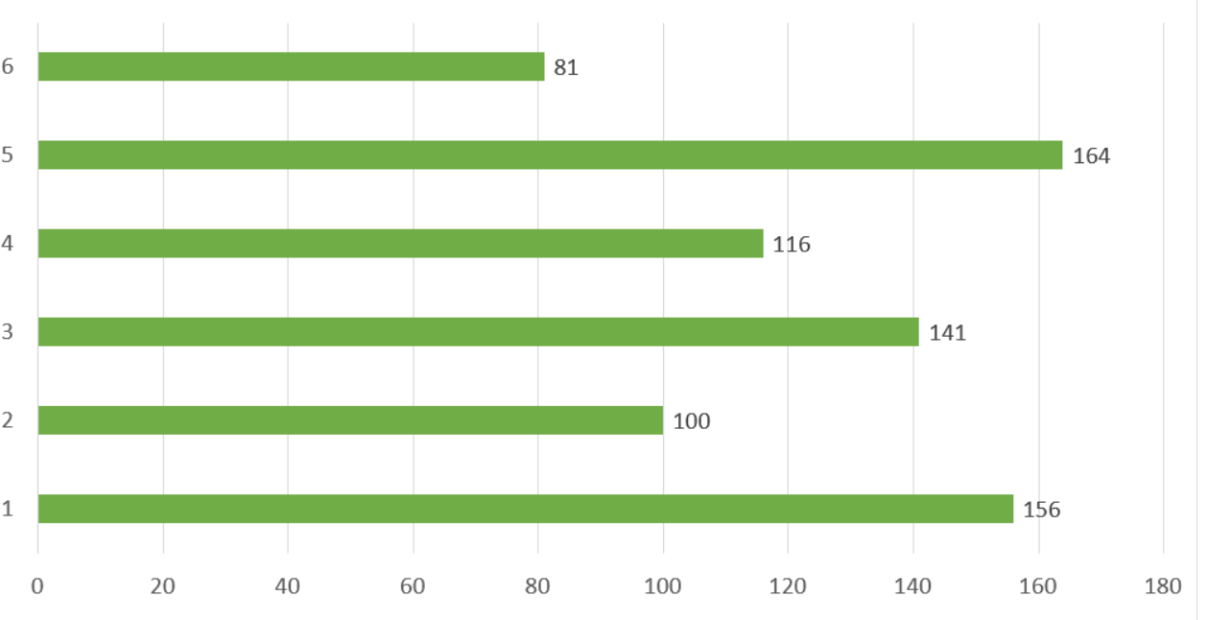

3. Line Chart
Definition: Shows trends over time using points connected by lines.
Use Case: Track stock prices over a year.

4. Pie Chart
Definition: Displays data as slices of a circle to show proportions.
Use Case: Show market share of different companies.

5. Doughnut Chart
Definition: Similar to a pie chart but with a hole in the center.
Use Case: Display proportion of expenses in a monthly budget.

6. Area Chart
Definition: Similar to line chart but the area under the line is filled.
Use Case: Show cumulative sales over time.

7. Scatter Chart (XY Chart)
Definition: Plots individual data points to show relationships between two variables.
Use Case: Analyze correlation between study hours and exam scores.

8. Bubble Chart
Definition: Similar to scatter chart but with varying bubble size to represent a third dimension.
Use Case: Visualize sales revenue (size) against number of units sold (x-axis) and profit margin (y-axis).

- What are the different chart formattings we can do in Excel
ANS:
Chart Formatting in Excel
After creating a chart in Excel, you can format it to make it more readable, visually appealing, and professional. Formatting helps highlight important data and improves clarity.
Different Chart Formatting Options in Excel
- Chart Title
  - Add, edit, or format the chart title.
  - Options: font, size, color, and position.
- Axis Titles
  - Label X-axis (horizontal) and Y-axis (vertical).
  - Format text, font, color, and alignment.
- Data Labels
  - Show actual values on each data point/bar.
  - Position: above, inside, or outside bars/columns/points.
- Legend Formatting
  - Indicates what each color/series represents.
  - Move position (top, bottom, left, right) and change font style/color.
- Gridlines
  - Customize horizontal/vertical gridlines for clarity.
  - Change line style, color, or remove them.
- Data Series Formatting
  - Modify color, pattern, or style of bars, columns, lines, or markers.
  - Add effects: shadows, 3D effects, or gradients.
- Chart Area & Plot Area
  - Chart Area: Entire chart background (fill, border, effects).
  - Plot Area: Area where data is plotted (format separately).
  - Can format font, alignment, and borders.
- Trendlines
  - Show patterns or predictions in data.
  - Options: linear, exponential, moving average, etc.
- Axes Formatting
  - Change scale, number format, min/max values, and tick marks.
  - Makes data easier to interpret.
- Chart Styles and Themes
  - Apply pre-defined styles and color themes.
  - Accessible via Chart Tools → Design tab.
10.How do we hide and show legends and data tables in Excel
ANS:
Hiding and Showing Legends in Excel
Definition:
A legend shows what each color or series in a chart represents. You can hide or display it as needed.
Steps to Hide or Show Legend:
- Click on the chart.
- Go to Chart Tools → Design / Format tab (or use the plus “+” icon on the top-right of the chart).
- Click Legend.
- Choose one of the options:
  - Show Legend → Display the legend.
  - Hide Legend / None → Remove the legend from the chart.
- You can also move the legend to top, bottom, left, or right from the same menu.

Hiding and Showing Data Tables in Excel
Definition:
A data table displays the actual values of the chart series below the chart.
Steps to Hide or Show Data Table:
- Click on the chart.
- Click the chart elements icon (plus “+” sign) at the top-right of the chart.
- Check or uncheck Data Table to show or hide it.
- Optional: Click the arrow next to Data Table to choose options like Show with Legend Keys.

Shortcut:
- Hover over the chart → Click the “+” icon → Quickly toggle Legend and Data Table visibility.

Unit 4
- What are Pivot tables and what are their applications in Excel
ANS:
A Pivot Table is a powerful Excel feature that allows you to summarize, analyze, and explore large sets of data quickly. It helps to reorganize data dynamically without changing the original dataset.

Key Features:
- Summarizes large datasets in rows and columns.
- Allows calculations like sum, average, count, min, max.
- Can filter, sort, and group data easily.
- Enables creating interactive reports..

Applications / Uses of Pivot Tables:
- Summarizing Large Data Sets
  - Quickly calculate totals, averages, counts, or percentages.
  - Example: Calculate total sales for each product category.
- Analyzing Trends
  - Compare data over time to detect patterns.
  - Example: Track monthly sales trends for multiple products over a year.
- Filtering and Segmentation
  - Focus on specific subsets of data using filters or slicers.
  - Example: View sales data for a particular region or salesperson.
- Grouping Data
  - Group numbers, dates, or categories for better insights.
  - Example: Group daily sales into months or quarterly totals.
- Creating Interactive Reports and Dashboards
  - Generate dashboards with multiple Pivot Tables and charts for presentations.
  - Example: Show product-wise revenue along with percentage contribution.
- Detecting Outliers and Patterns
  - Easily spot unusually high or low values.
  - Example: Identify products with unusually high returns or low sales.
- Quick Decision Making
  - Managers and analysts can make faster decisions based on summarized data.
  - Example: Decide which product line needs promotion based on sales performance.

- What are Pivot charts and what are their applications in Excel
ANS:
Pivot Charts in Excel
Definition:
A Pivot Chart is a graphical representation of the data in a Pivot Table. It allows users to visualize summarized data interactively and see trends, comparisons, and patterns quickly. Pivot Charts are dynamic; when you update or filter the Pivot Table, the Pivot Chart automatically updates as well.

Key Features of Pivot Charts:
- Automatically reflects changes in the linked Pivot Table.
- Allows drilling down, expanding, or collapsing categories.
- Supports column, bar, line, pie, and other standard charts.
- Can be controlled using filters or slicers for interactive reporting.
- Can group data by date, numbers, or categories directly from the Pivot Table.
- Allows customization of colors, labels, legends, and chart styles.

Applications / Uses of Pivot Charts:
- Visualizing Sales Data
  - Quickly compare sales across products, regions, or time periods.
  - Example: Show monthly sales trends of different products using a line chart.
- Performance Analysis
  - Analyze employee performance, departmental KPIs, or project metrics.
  - Example: Visualize the number of tasks completed by different teams.
- Trend Analysis
  - Detect patterns or changes over time in large datasets.
  - Example: Track revenue growth quarter-wise across multiple regions.
- Interactive Reporting
  - Provide interactive dashboards with slicers for filtering by categories or periods.
  - Example: A manager can filter by region and instantly see product sales in a chart.
- Comparative Analysis
  - Compare multiple data series side by side for easy insights.
  - Example: Compare monthly sales of different stores using a clustered column chart.
- Decision Making Support
  - Helps stakeholders make data-driven decisions by visualizing key metrics.
  - Example: Identify low-performing products or regions and plan strategies accordingly.

- What are different setting options in Pivot table and do we calculate sub Totals in Pivot table
ANS:
Different Setting Options in a Pivot Table
- Grand Totals
  - Display or hide grand totals for rows and columns.
  - Provides overall summary of data.
- Filters
  - Report Filter: Filter data by criteria at the top.
  - Slicers: Interactive buttons for visual filtering.
  - Timelines: Filter date-based data interactively.
- Show Values As
  - Change how values are displayed without altering source data.
  - Examples: % of Row Total, % of Column Total, Difference From, Rank, Running Total.
- Number Formatting
  - Format numbers, currency, percentages, or custom formats for readability.
- Sort & Filter
  - Sort data ascending/descending.
  - Apply Label Filters (contains, begins with) or Value Filters (greater than, top 10).
- Field Settings
  - Decide calculation type: Sum, Average, Count, Max, Min, Product, etc.
  - Set how items are shown in rows or columns.
- Refresh
- Updates the Pivot Table when source data changes.
- Ensures analysis reflects the latest data.
Calculating Subtotals in Pivot Table:
- Subtotals are calculated automatically for grouped fields.
- You can customize subtotals for each field.
- Example: If you have sales data grouped by Region, Excel can calculate the subtotal for each Region automatically.
- Subtotals can be displayed at the top or bottom of each group, or hidden if not needed.

- What are the different manipulations that we can do with spreadsheets in Excel
ANS:
Different Manipulations in Excel Spreadsheets


Hiding a Worksheet
Definition: Temporarily removes a sheet from view without deleting it.
Steps:
- Right-click on the sheet tab → Hide.
- To unhide: Right-click any tab → Unhide → select sheet → OK.

Protecting a Worksheet
Definition: Restricts editing of sheet data, formulas, or formatting.
Steps:
- Go to Review tab → Protect Sheet.
- (Optional) Enter password & choose allowed actions.
- Click OK → Sheet is protected.

- Write steps for Freezing Panes, Copying and Pasting Data between Spreadsheets in Excel
ANS:
1. Freezing Panes:
- Purpose: Keep rows or columns visible while scrolling.
Steps:
- Select the cell below the rows and right of the columns you want to freeze.
- Go to the View tab → Freeze Panes.
- Choose:
  - Freeze Panes – freezes above and to the left of the selected cell.
  - Freeze Top Row – keeps the top row visible.
  - Freeze First Column – keeps the first column visible.

2. Copying Data Between Spreadsheets:
Steps:
- Open both source and destination spreadsheets.
- Select the cell(s) to copy.
- Press Ctrl + C or right-click → Copy.
- Go to the destination sheet and select the target cell.
- Press Ctrl + V or right-click → Paste.

3. Pasting Data Between Spreadsheets:
- Use Paste Special if needed:
  - Values – only data
  - Formulas – only formulas
  - Formats – only formatting

- Write steps for Hiding , Protecting worksheets in Excel
ANS:
1. Hiding Worksheets
Purpose: Hide a worksheet to prevent it from being visible but still keep it in the workbook.
Steps:
- Open the workbook containing the worksheet you want to hide.
- Right-click on the sheet tab at the bottom of the worksheet.
- Click Hide from the context menu.
- The sheet disappears from view but still exists in the workbook.
To Unhide a Worksheet:
- Right-click on any visible sheet tab.
- Click Unhide.
- In the Unhide dialog box, select the worksheet you want to make visible.
- Click OK.

2. Protecting Worksheets
Purpose: Prevent accidental or unauthorized changes to the data in a worksheet.
Steps:
- Open the worksheet you want to protect.
- Go to the Review tab on the Ribbon.
- Click Protect Sheet.
- In the dialog box:
  - Enter a password (optional) to prevent others from unprotecting.
  - Choose the actions users are allowed to perform (e.g., select locked/unlocked cells, format cells, insert rows/columns).
- Click OK.
- If you entered a password, re-enter it to confirm and click OK.
To Unprotect a Worksheet:
- Go to the Review tab → Unprotect Sheet.
- Enter the password (if any) and click OK.

- What are the different ways to do sorting in Excel
ANS:
Definition:
Sorting in Excel is the process of arranging data in a specific order, either ascending or descending, to make it easier to analyze and understand. Sorting can be based on text, numbers, dates, or even cell colors and icons.

Different Ways to Do Sorting in Excel
- Sort Ascending (A → Z / Smallest → Largest):
  - Arranges data in increasing order.
  - Text: A to Z
  - Numbers: Smallest to Largest
  - Dates: Oldest to Newest
- Sort Descending (Z → A / Largest → Smallest):
  - Arranges data in decreasing order.
  - Text: Z to A
  - Numbers: Largest to Smallest
  - Dates: Newest to Oldest
- Custom Sort:
  - Go to Data → Sort → Custom Sort.
  - Allows sorting by multiple columns or specific order.
  - Example: Sort first by Department, then by Employee Name.
- Sort by Cell Color, Font Color, or Icon:
  - Useful when conditional formatting is applied.
  - Sorts data based on colors or icons rather than values.
- Sort Left to Right:
  - Sorts data horizontally across rows instead of columns.
  - Go to Data → Sort → Options → Sort left to right.
- Sort Using Filters:
  - Apply Filter from Data → Filter.
  - Click the dropdown arrow on a column and choose Sort A to Z or Z to A.

- What are different ways to do filtering in Excel
ANS:
Filtering in Excel
Definition:
Filtering in Excel is the process of displaying only the data that meets certain criteria while hiding the rest. It helps to focus on specific information in a large dataset without deleting any data.

Different Ways to Do Filtering in Excel
- AutoFilter (Standard Filter):
  - Go to Data → Filter.
  - Click the dropdown arrow on a column to select specific values to display.
  - Example: Show only sales above 5000.
- Text Filters:
  - Filter text-based data using options like:
    - Equals
    - Contains
    - Begins With / Ends With
  - Example: Show all products containing “Pen”.
- Number Filters:
  - Filter numeric data using options like:
    - Equals, Greater Than, Less Than
    - Between, Top 10, Above Average
  - Example: Show all employees with salary > 50,000.
- Date Filters:
  - Filter date-based data using options like:
    - Before / After / Between
    - This Week, Last Month, Next Year
  - Example: Show orders placed in the current month.
- Custom Filter:
  - Combine multiple criteria for advanced filtering.
  - Example: Show sales > 5000 and region = “East”.
- Filter by Color or Icon:
  - Filter data based on cell color, font color, or conditional formatting icons.
- Advanced Filter:
  - Go to Data → Advanced for filtering data to another location or using complex criteria ranges.

- How do we convert text to column in excel write steps
ANS:
Converting Text to Columns in Excel
Purpose:
The Text to Columns feature splits data in a single column into multiple columns based on a delimiter or fixed width.

Steps to Convert Text to Columns:
- Select the Data:
  - Highlight the column containing the text you want to split.
- Go to Text to Columns:
  - Go to the Data tab on the Ribbon.
  - Click Text to Columns in the Data Tools group.
- Choose Conversion Type:
  - Delimited: Data is separated by characters like comma, space, tab, or semicolon.
  - Fixed Width: Data is split at specific positions.
  - Click Next.
- Set Delimiters (if Delimited):
  - Select the delimiter(s) used in your data (e.g., Comma, Space, Tab).
  - You can see a Data preview of how the data will split.
  - Click Next.
- Set Column Data Format:
  - Choose General, Text, or Date for each column.
  - You can skip columns if needed.
  - Click Finish.
- Check Result:
  - Your original column is now split into multiple columns as per the delimiter or fixed width.
Example:
Original Data in Column A:
John,Doe,25,New York
Jane,Smith,30,Los Angeles
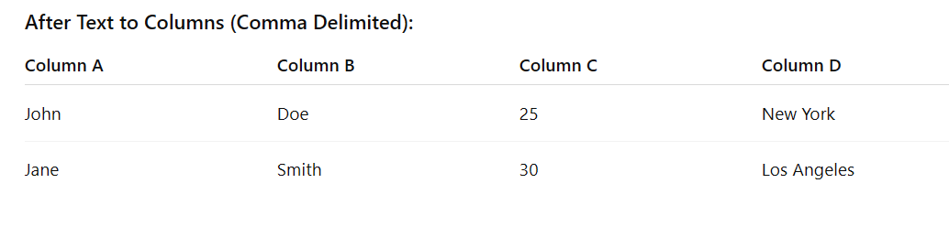
10.What are the ways to do data validation in Excel
ANS:
Data Validation in Excel
Definition:
Data Validation is a feature in Excel that restricts the type of data or values a user can enter into a cell. It helps prevent errors and ensures data consistency.

Ways to Do Data Validation in Excel
- Whole Number:
  - Restrict input to whole numbers within a specified range.
  - Example: Only allow numbers between 1 and 100.
- Decimal:
  - Allow decimal numbers within a range.
  - Example: Only allow values between 0.5 and 9.5.
- List:
  - Create a dropdown list of predefined values.
  - Example: Select from “Male, Female, Other.”
- Date:
  - Restrict input to dates within a specific range.
  - Example: Only allow dates between 01/01/2024 and 31/12/2024.
- Time:
  - Restrict input to times within a certain range.
  - Example: Only allow times between 09:00 AM and 05:00 PM.
- Text Length:
  - Limit the number of characters in a cell.
  - Example: Only allow text with 10 characters or less.
- Custom:
  - Use a formula to create complex validation rules.
  - Example: Only allow values where =MOD(A1,2)=0 (even numbers).

Steps to Apply Data Validation:
- Select the cell(s) to validate.
- Go to Data → Data Validation → Data Validation.
- In the Settings tab, choose the validation type (Whole Number, Decimal, List, Date, Time, Text Length, Custom).
- Set the criteria or formula.
- (Optional) In the Input Message tab, write a message to guide users.
- (Optional) In the Error Alert tab, write a message to show if invalid data is entered.
- Click OK.

Example:
- Cell A1: Data validation using List → “Yes, No”
- Result: User can only select Yes or No from a dropdown.

